Michael Dandrea

1. Segmentation divides a program into different segments, where each segment represents a logical unit such as a function, procedure, or data structure. Each segment has its own size and is allocated a separate area in the memory. Segmentation provides a way to organize and manage memory based on the logical structure of a program.

Paging divides memory into fixed-size blocks called pages. Similarly, programs are divided into fixed-size blocks called frames. The operating system keeps track of these pages and frames through page tables, which contain the mapping between logical addresses and physical addresses.

* 1. The size is 8 \* 1024 words/page = 8192 words. We need log2(8192) = 13 bits in the logical address.
  2. Each frame has a size of 1024 words, so the physical memory is 32 \* 1024 = 32768 words. We need log2(32768) = 15 bits, so there are 15 bits in the physical address.

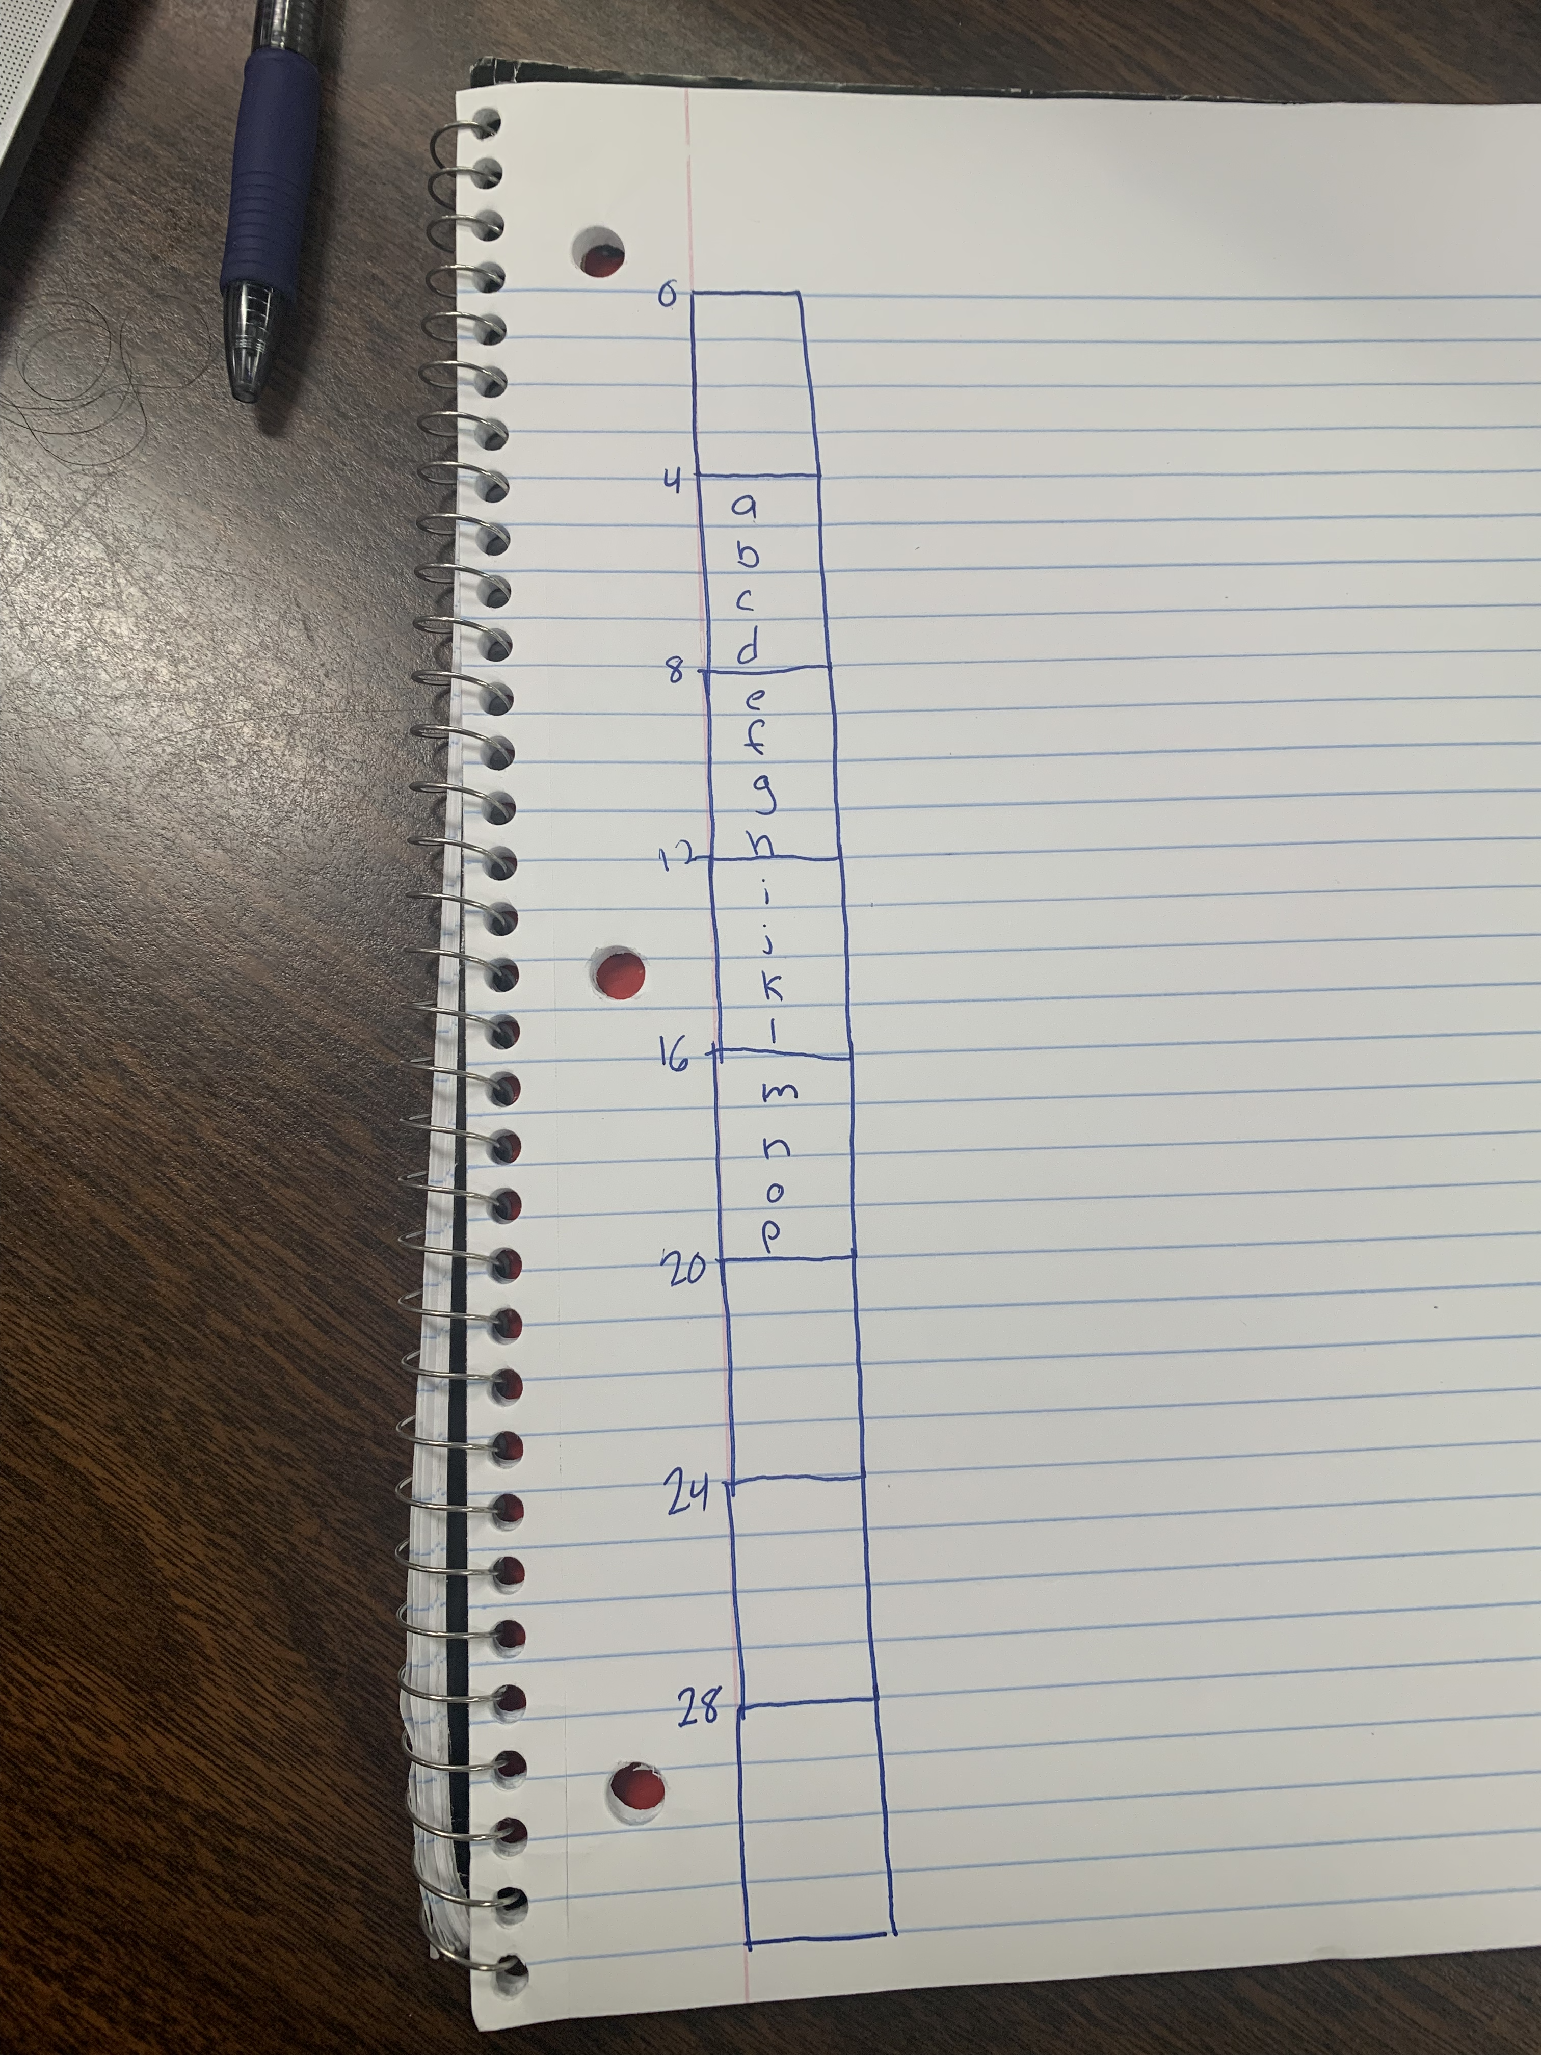

* 1. 415 + 275 = 690.
  2. 1350 + 50 = 1400.
  3. 300 nanoseconds: 2 x memory reference time
  4. 180 nanoseconds: .8(0+150) + .2(0 + 150 + 150)